IS487 – Lab Tutorial
State Management (Provider) and Local Persistence
Course: IS487 – Emerging Topics in IS
Lab Focus: The focus of this lab is to master Global State Management and Data Persistence in a multi-page Flutter application. Specifically, students will learn how to transition from a "temporary" app (where data disappears on refresh) to a "permanent" app (where data is stored in the browser).
Primary Learning Objectives
1. State Sharing with Provider
The lab emphasizes moving data out of individual widgets and into a central Provider.
- The Problem: Passing data manually between LoginScreen and HomeScreen is messy and difficult to maintain.
- The Solution: Using ChangeNotifierProvider to create a "Single Source of Truth." Students will learn the difference between context.read (performing actions) and context.watch (listening for updates).
2. Local Storage Persistence
A major focus is using the localstorage package to interact with the browser's disk.
- Initialization: Understanding why await initLocalStorage() is required in the main function for Web apps.
- Serialization: Learning how to use jsonEncode and jsonDecode to turn complex objects into strings that a database can store.
3. Modular Code Structure
The lab forces students to organize code into a professional folder structure:
- Models: For data blueprints.
- Providers: For logic and data handling.
- Widgets: For reusable UI components (like the CustomInput).
- Pages: For the actual screens.

The Architecture
lib/
├── models/
│ └── user_model.dart
├── providers/
│ └── user_provider.dart
├── pages/
│ ├── home_page.dart
│ └── login_screen.dart
└── main.dart
Before coding, understand the "Flow":
- Model: Defines the data structure.
- Widget: The reusable UI components.
- Provider: The "Brain" that holds data and saves it to disk.
- Main: The "Engine" that starts everything.
- Screens: The "Face" of the app.

Step 1: The Model (The Data Container)
File: lib/models/user_model.dart. We need to convert our class into a Map (JSON) so it can be saved. This model allows us to convert your data between a Dart Object and a JSON map.
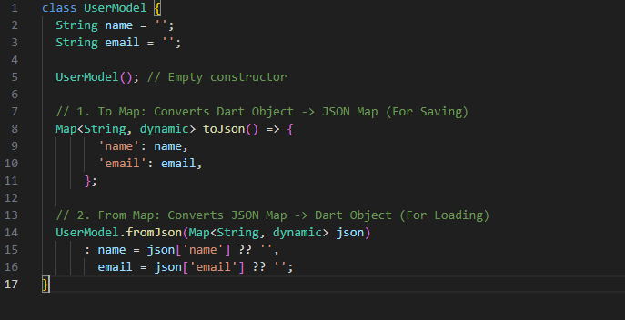

Step 2: The Reusable Widget (Clean Code)
File: lib/widgets/custom_input.dart Instead of writing 20 lines for every TextField, we create a template. We pass a TextEditingController from the parent to the child.
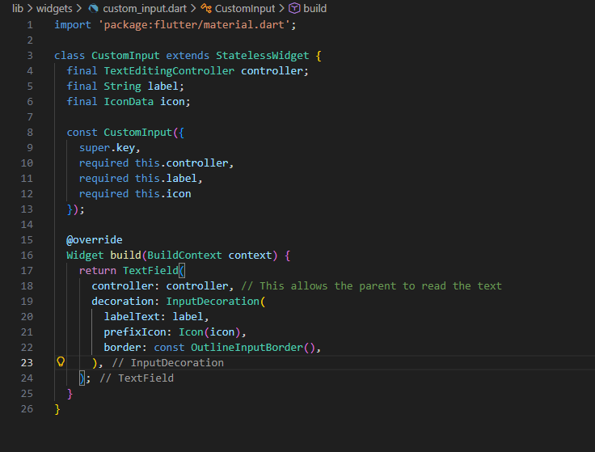

Step 3: The Provider (Logic & Storage)
File: lib/providers/user_provider.dart This class extends ChangeNotifier. When data changes, we call notifyListeners(), which acts like a "shout" telling all screens to update.
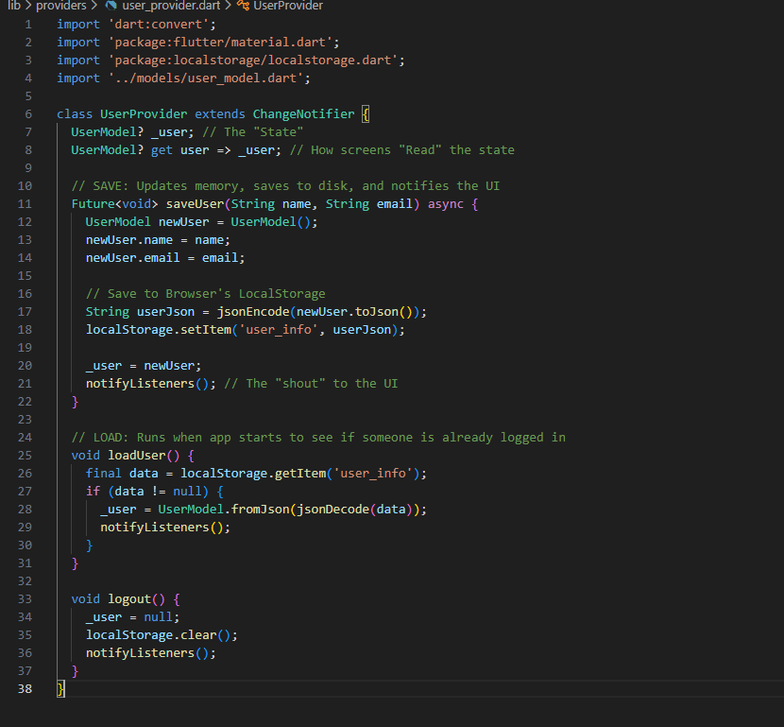

Step 4: The Entry Point (Initialization)
File: lib/main.dart On the Web, the app must wait for the storage engine to wake up. We use await initLocalStorage() inside an async main.
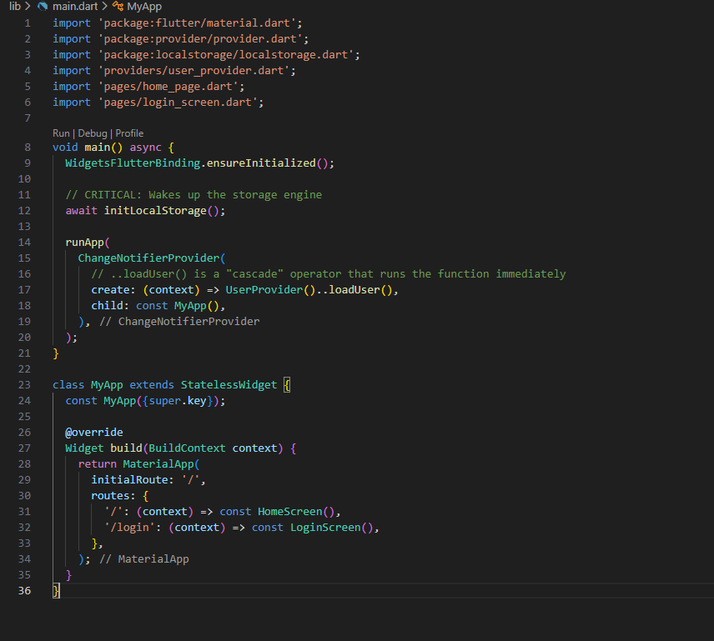
In programming, "Synchronous" means tasks happen one after another. Which means if one task takes 5 seconds, the whole app freezes for 5 seconds. Asynchronous (async/await) allows Flutter to start a slow task (like saving to a database) and "pause" that specific function while the rest of the app stays active and smooth.
Why this is vital for storage:
1. The "Main Thread" Problem
Flutter runs your UI on a single "Main Thread." If you try to save a large file to the browser's disk synchronously, the "Main Thread" stops drawing the screen to focus on the disk. To the user, it looks like the app crashed or the button "stuck."
By using async, you tell Flutter: "Go save this user data in the background. Don't stop the animations or the user's ability to scroll while you do it."
2. How await works in your Provider
In the UserProvider, we use await specifically because we cannot predict how long the browser will take to write data to the physical hard drive.
3. Handling the "Future"
When a function is marked async, it returns a Future. Think of a Future like a "receipt" for a pizza. You don't have the pizza yet, but you have a promise that it will arrive.
- async: Declares that this function will contain a "waiting" period.
- await: The act of waiting for the "pizza" (the data) to arrive before moving to the next line of code.
4. Why await initLocalStorage() is special
In the main.dart, we used await initLocalStorage(). This is a unique case where we want the app to stay on the splash screen (white screen) until the storage is ready.
If we didn't use await here, the app would try to load the user's name from a database that isn't even open yet, leading to the "Late Initialization Error".
5.WidgetsFlutterBinding.ensureInitialized()
It tells the Framework: "Wake up the Engine and make sure we are connected to the platform (browser) right now."
When you call initLocalStorage(), the Dart code has to send a message to the browser to ask for access to the disk. Dart cannot talk to Chrome if the "Binding" isn't initialized yet.
If you delete that line, Flutter tries to talk to the browser before the "phone line" is plugged in. The app will throw an error saying:
"ServicesBinding.defaultBinaryMessenger was accessed before the binding was initialized."
The "Normal" vs. "Async" Main
- Normal Main: If your main() is just void main() => runApp(MyApp());, you don't need this line. Why? Because runApp() calls it for you automatically as the very first thing it does.
- Your Main: Because the main() asynchronous to wait for the storage (await initLocalStorage()), you are running code before runApp(). Therefore, you must manually call ensureInitialized() to make sure the system is ready for those early commands.

Step 5: The Screens (UI)
The Home Page (lib/pages/home_page.dart)
This screen "watches" the provider and reacts when the user logs in or out.
Uses context.watch<UserProvider>(). This means: "Whenever the Provider calls notifyListeners, redraw this screen."

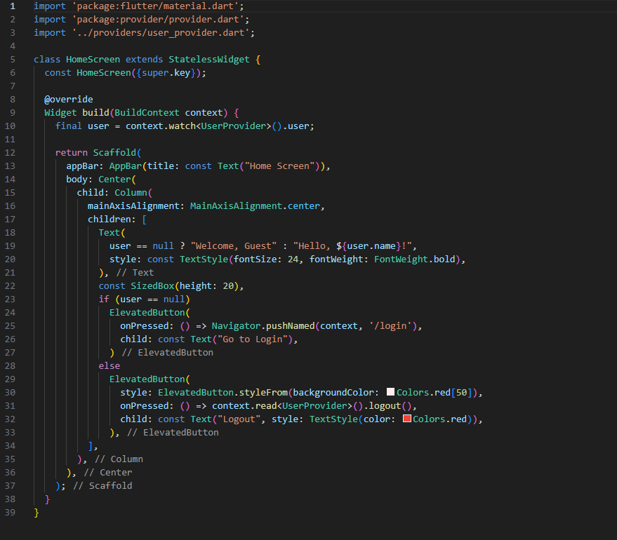

The Login Screen (lib/pages/login_screen.dart)
Uses context.read<UserProvider>(). This means: "I just want to call a function (saveUser), I don't need to listen for changes here."

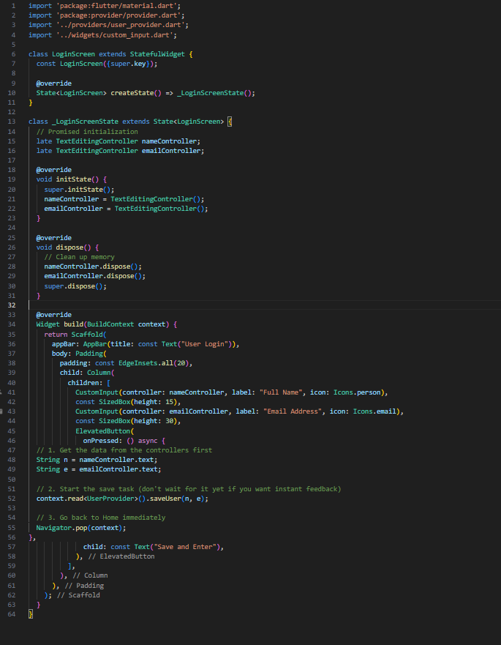
Step 6: add a web_dev_config.yaml file at root of your project and following contents:
server:
port: 8080 # Specifies the port

Since we are using localstorage and the provider , you have to add them to your application by running the appropriate commands in the terminal.
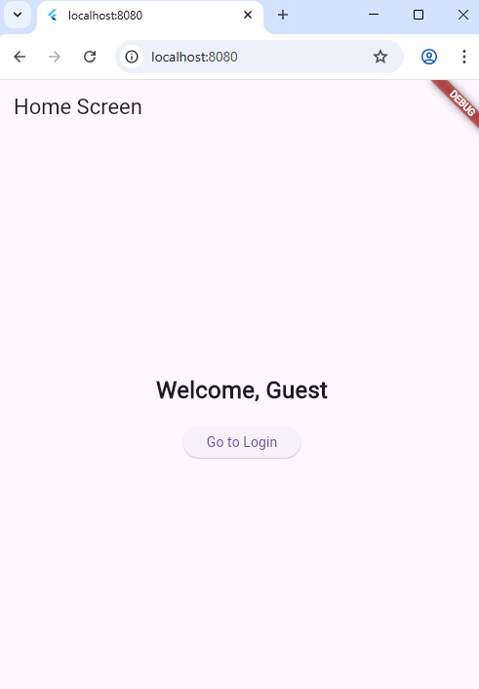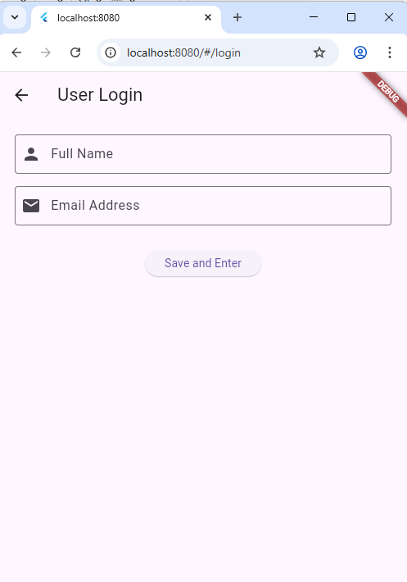

Skill | Description
Asynchronous Programming | Using async and await to handle storage operations without freezing the UI.
Object Modeling | Creating toJson() and fromJson() methods to bridge the gap between Dart and JSON.
Widget Composition | Building a CustomInput widget that accepts a TextEditingController as a parameter.
Navigation | Implementing named routes and managing the Navigator stack.
Key Technical Skills Covered

